Carbon management in forests:
“Good forest management is good carbon management”

First of all, the climate is changing. Any student of history will know that it was quite a bit warmer during the Medieval Ages, when wine grapes were grown in northern Germany, and Greenland was being settled by Vikings. The 1200’s saw some cooling, and then we had the Little Ice Age from about 1550 to 1800. The last time the Thames river froze over was 1804, and then we had the “year without a summer” in 1816. It has been warming since, and most scientists agree that atmospheric carbon was not raised significantly until the 1940’s or so. But we had warming in the 1920’s and 30’s, cooling in the middle of the century, and we’ve all been made aware of recent warming. Experts warned of a coming ice age in the 70’s, global warming in the 80’s, and now they call it climate change since, well, the climate is changing.

I admit that I am a skeptic of current claims that man-made carbon will overheat the whole planet. If the science is settled, then why do we spend $30 billion on climate research each year? We don’t spend that much to research gravity, because that is fairly well understood. And we certainly don’t have a full comprehension of how water vapor functions as a greenhouse gas, or the role in clouds reflecting heat, and trapping heat. What are the positive and negative feedback mechanisms on changing temperatures? I think it is safe to say that 97% of scientists agree that we should spend more money on “science”. There may be some “money pollution” in the climate science industry.

We live in a world that thinks atmospheric carbon is an important topic, and regardless of whether you are a “true believer” or a “skeptic” like me, forest management is carbon management. We should be ready and willing to address our neighbors with the thought that managing forests is good for the environment, and that it is good carbon management. From a carbon perspective, forestland is the very best land use, and we can make a strong argument that good forest management provides a crisp economic incentive for forests to stay forested.

The basic carbon cycle is fairly easy to explain. The details get complicated. As trees grow, they pull carbon dioxide out of the air and combine it with water to create sugars and release oxygen. That is wonderful. The trees also burn their sugars, using oxygen and releasing CO2. The extra sugars get converted to cellulose and other chemicals that form the wood in the tree. We measure that as the growth in the forest, in cords, boards and tons. Of course, there are roots underground, dead trees and partially decayed organic matter which add to the forest’s carbon storage. When trees die, they slowly release their carbon, and use up the same amount of oxygen they produced. When we harvest trees, most of the wood is on a short cycle to be burned or disposed of in some way that returns the carbon to the atmosphere. A portion ends up as “durable wood products” like housing or furniture which might store the carbon for a century or more. And, the timber industry runs on diesel fuel. Accounting for this entire carbon cycle can be incredibly complex.

Overall, forests are generally growing. In each state, growth exceeds harvests by a comfortable margin and that is good news from a carbon perspective. Some would say, however, that we should merely let these forests continue to grow and store additional carbon, maximizing the forest stocking, and minimizing the carbon that gets released through harvesting. The practical “tree-huggers” would allow us to cut a tree just before it dies and rots. Let me offer a series of antidotes to this proposal.

Mortality: Everyone wants to talk about “net forest growth” but no one wants to talk about forest mortality. Young forests grow faster, storing more carbon each year with low mortality (as measured in tons). As forests get older and more crowded, the mortality increases and net growth slows and even stops in some cases. And these unhealthy old forests are prone to events, like storm damage and forest fires. If we leave forests alone to merely store carbon, then they do just that and little else from a carbon perspective. The additional carbon storage -net growth- declines. Since we harvest less than total growth, our forests around the country, on average, are becoming overcrowded. In Vermont, with harvests at about 40-50% of growth, we have seen mortality double in about 30 years due mostly to crowding. Massachusetts harvests only about 12% of its growth rate and has an even higher mortality rate. Both states have about a million cords rotting each year. If it was not so wet, we would have forest fires like the folks in Oregon and Montana. Nationwide, forest mortality is well over 140 million tons per year. Whether the forests burn or rot, most of that carbon is released into the atmosphere.

Forest fires: This subject warrants its own paragraph. The west is burning up, again. While the south had its hurricanes and flooding to destroy lives, homes, and property, many more people were affected in similar ways by forest fires throughout the western US, with little news coverage. There are 50-80 million acres of forest at risk of conflagration across the country. Overcrowding is undeniably a main factor, and this is made worse in dry forest types where trees compete for moisture as well as sunlight. Burning 5-10 million acres of wildfire per year releases as much as a half-billion tons of carbon dioxide in the initial fires plus the subsequent decay, or burning, of the dead stems left behind. This is almost 10% of the entire country’s emissions. Wildfire is not “nature’s groovy way” to regenerate the forests, and cause all sorts of environmental harm to water quality, wildlife habitat, soils, and other forest benefits. If carbon management is important, then this is the low-hanging fruit. Much of the excess stocking is only suitable for biomass or paper, but some can be used for lumber or other products, slowing the release of carbon. In any case, these dead and dying forests can be replaced with the rapid growth (additional carbon storage) of young trees.

Biomass energy: Here is another controversial subject, and some would go as far as to say that burning coal is better for the atmosphere than burning biomass. There is a grain of truth there. Biomass is “low density” and contains moisture, such as green chips. This makes for less efficient burning, requiring more fuel to make one kW of electricity, so it actually releases more carbon to burn wood than coal. If we just had a pile of wet wood-chips and a pile of coal, burning the coal produces less carbon per unit of energy. But if those chips come from managed forests, and are the waste product from producing other forestry benefits, then even at low efficiency such as large-scale electric generation (which is about 25% efficient) then there is an atmospheric benefit to replace fossil fuel. Biomass carbon would have been released anyway, without replacing any fossil fuels. Of course, higher efficiency is better in some ways, and dry pellets, dry cordwood, and thermal use of green chips all score more highly. Large scale biomass has one strong point, and that is the scale. Hundreds of millions of acres have problems with overcrowding, and this cannot be solved with small-scale solutions.

Keeping forests forested: This is the most important concept, and even the tree-huggers agree. A forest, managed or unmanaged, pine plantation or wilderness, is the best land-use for carbon management compared to anything else. We can argue about the details, and I hope we will! Forests generally grow, storing carbon in the trees but also in the soils. Converting to other uses releases most of that carbon. And, of course, forests provide a wide range of other benefits. But what is the economic reality of keeping your land? America is one of the places where ordinary citizens can own forestland. Through all of history and around the world, only the wealthy and governments typically own forests. One aspect of this is the dividend paid by the managed forest, which pays the taxes, management fees, and hopefully some return on the investment. So even if the carbon “tons per acre” are lower in a managed forest, it is still better than converting to any other use.

Durable Wood Products: Good forest management increases the proportion of wood that will be in long term storage for housing, furniture, etc. It is true that a large percent of harvested wood returns to the atmosphere in a short time, perhaps a decade. The tops and branches decay or are burned as fuel. Low quality and smaller trees can be used for firewood, pellets or bio-fuels, but end up as atmospheric carbon. Slabs and scraps from making lumber are often converted to paper, along with low quality logs, and very little of that ends up on your bookshelf – so it goes back into the atmosphere in a decade or less. A well-managed forest will produce a higher percent of those durable products which might be “in storage” for a century or more, such as structural lumber, or furniture. More important is the carbon use of the products that wood replaces. Every other raw material in common use requires more energy to manufacture and process than wood. Metals, plastic, concrete and even raw stone take huge amounts of energy, usually releasing carbon in the process. So, your wood table might store 100 pounds of carbon dioxide, but if it were made from aluminum, at ¼ the weight, it would still release 4 or 5 times the carbon in its manufacturing. This makes carbon accounting, with any reliability, very complex.

Balanced Age Classes: If we are going to manage our forests well with carbon in mind, we should be producing a higher percent of durable wood products, and using our by-products to replace fossil fuels. If you are a follower of this magazine, you have seen a dozen articles on practical silviculture. One aspect is to have, across the landscape, a balance of young, middle-aged and older forests. There will be areas we choose not to manage, and they can always serve as a bad example, such as our burning National Forests. You don’t need to do all this on your woodlot, but there are options for forests with several age classes mixed together. While old forests store more carbon per acre, young forests grow faster, and gain more carbon per acre, each year. The balance of age classes will produce a steady supply of all wood products, with a mix of rapid growth and long-term storage, along with a mix of wildlife habitats for food, cover and other needs. How does your woodlot fit into a regional view?

Exporting our wood demand: Wood is good. We should use more of it, compared to other raw materials as mentioned above. If we don’t manage our forests here, then we export our demand to other places where they might not care for the environment as much as we do, such as Siberia, Indonesia and South America. We have no control over what they do, other than the products we choose, but we can influence our own region. In Massachusetts for example, they harvest 12% of their growth, and then import 90% of the wood they need. Some would like to limit forest management opportunity here, and they need to understand that we operate in a global system.

Other benefits of well managed forests: I don’t have to convince you. But you might have to convince someone else. Your forest, whether a newly regenerated pine stand, fully mature hardwoods, or uneven aged mixedwoods fits into the bigger picture mentioned above. It is providing habitat for wildlife, clean water for streams, and wood products for American families. If you love your land, then you will take good care of it, and hopefully pass it on to your children. And if it can pay its way with some income from forest management, then your kids will see it as a blessing instead of a curse, and will learn to love it as well. As my friend Bill Leak (Forest Service silviculture scientist for over 60 years) says: “Good forest management is good carbon management”.

To manage forests for carbon, here are some take-home points. Maintaining higher stocking stores more carbon, especially if you have two or three age classes in one stand. Structural diversity also gives the forest more resiliency for storm events, and ready replacement trees after a harvest. However, undesired shade tolerant species like beech can be a problem with these systems. Two-aged systems are quite useful, and easier to implement than truly uneven aged management. Growing trees to larger diameter, perhaps on extended rotations stores more carbon and increases your “durable products” proportion of the next harvest. Keep a balance of age classes over the landscape, which means looking beyond your borders. This fits well with wildlife habitat also. Retain coarse woody debris on your harvest site to provide delayed decay and build soil carbon. These are typically cull logs with little or no value. Also retain large legacy trees since they store many tons of carbon and provide other benefits like seed and habitat. Carbon management principles are easily integrated with other forestry goals, and forests are much more than merely carbon. You can take that to the bank.

Robbo Holleran is a private consulting forester helping landowners meet their goals in Vermont and adjacent areas. His work has him outdoors about 150 days each year, plus play time. He is one of the authors of the new Silvicultural Guide for Northern Hardwoods.

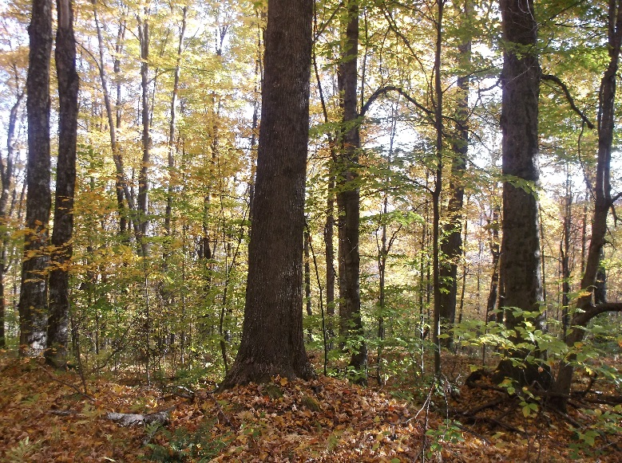
Uneven aged forests can retain high carbon levels and meet many forest management goals.
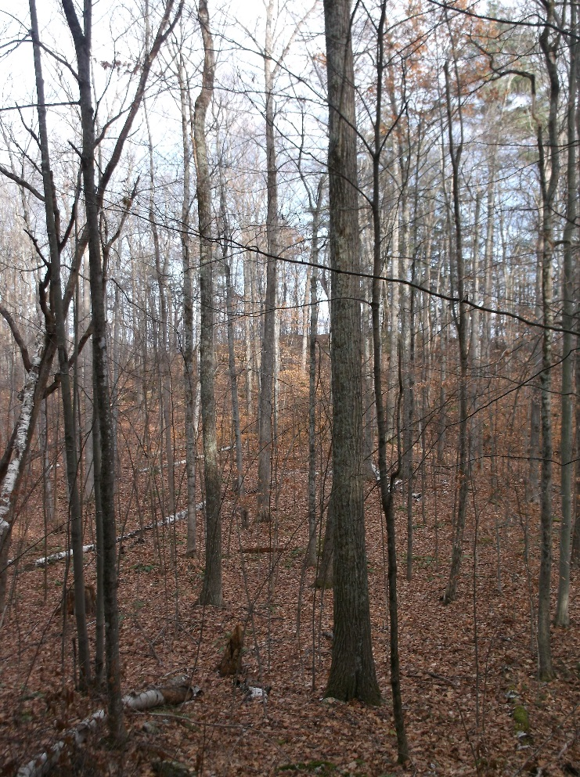

High quality growing adds value to the forest and increases the proportion of durable wood products you are growing.

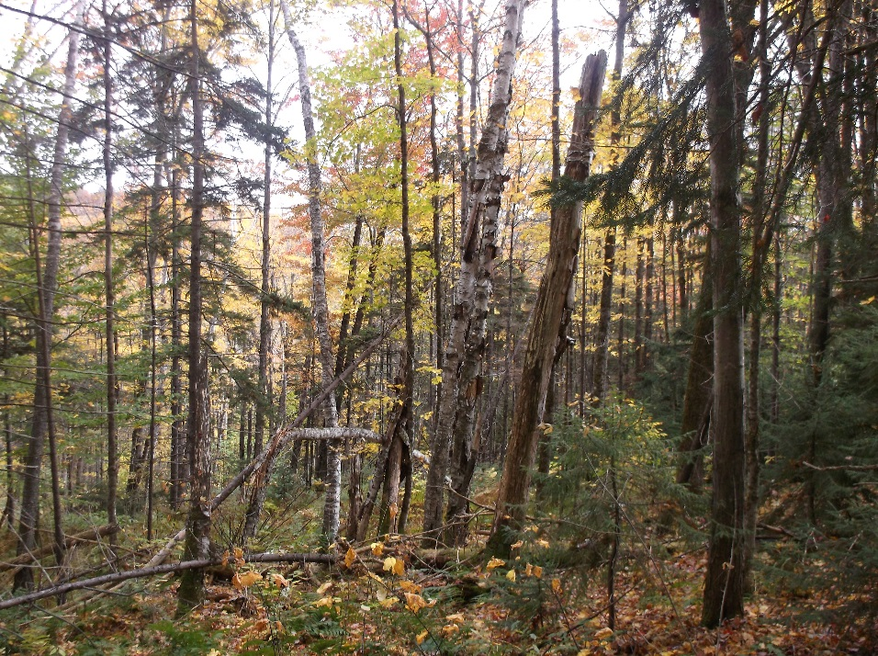
Mortality in the forest is normal, but overall levels are high and getting higher.

